Date | 28-09-2026
Team ID | SWTID-2026-7624
Project Name | Script-controlled ACL
Maximum Marks | 4 Mark

Phase-1 Brainstroming and Ideation

Brainstorming

Brainstorming is the first step of the project development process. It is a creative process in which different ideas are discussed to identify a problem and find possible solutions. In this project, brainstorming is used to understand how record access can be restricted based on the value of a particular field.

The main problem identified is that role-based access alone may not be sufficient to control access to every record. For example, records may belong to different departments such as IT, HR, and Finance. A user may need access only to records where the Department field is set to IT.

During brainstorming, the following ideas were considered:

- Restrict record access based on a specific field value.
- Use a script to make the access decision dynamically.
- Check the current user's role before allowing access.
- Combine user role and field value for better security.
- Allow or deny access depending on the conditions.
- Avoid creating many separate static ACL rules.

From these discussions, the idea of using a Script-Controlled ACL was identified as a suitable approach for providing flexible and dynamic record access control.

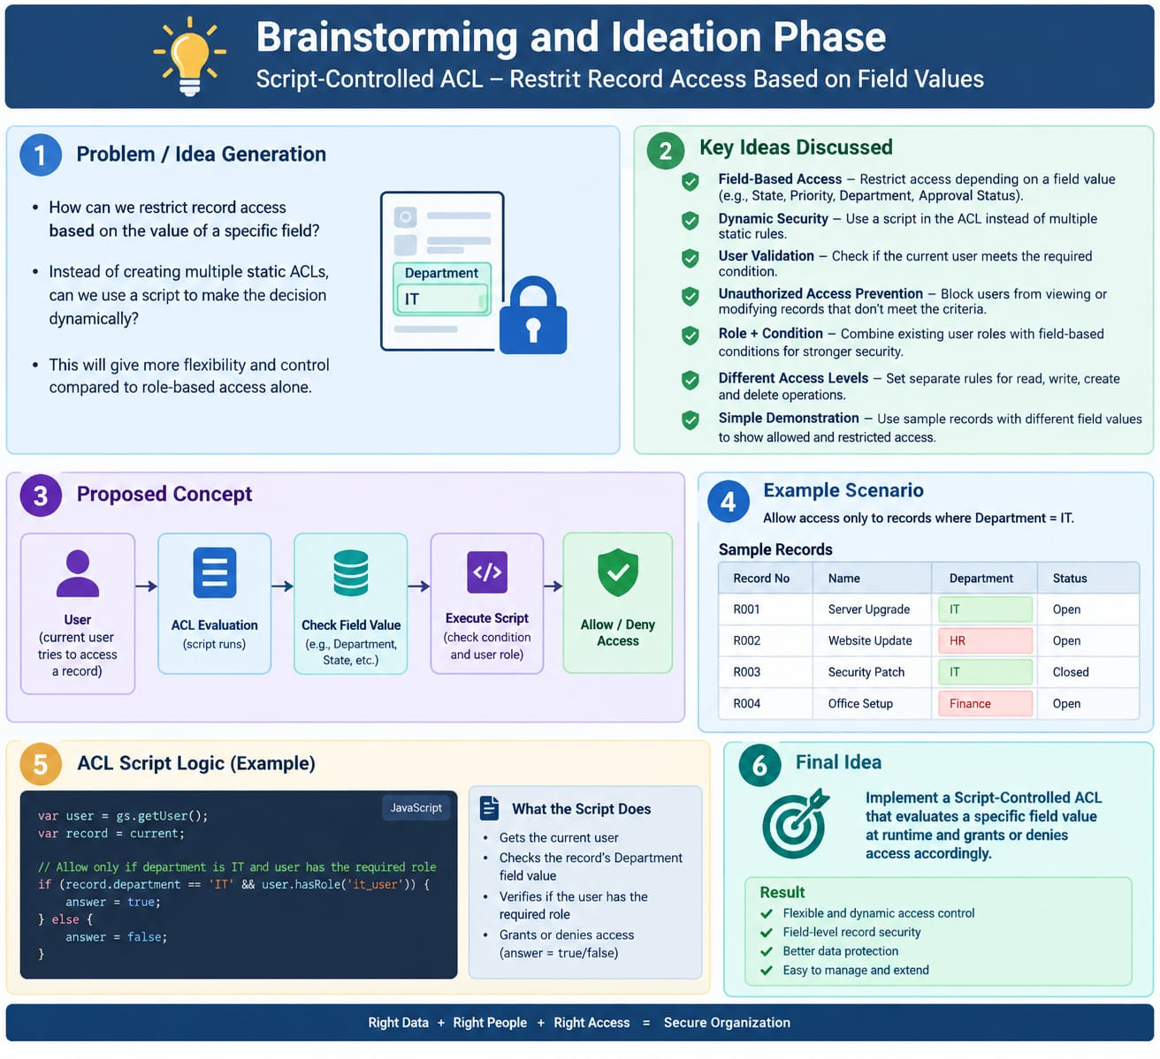

1. Problem Statement
In organizational and institutional environments, granting unrestricted access to sensitive data poses significant security risks. Standard Role-Based Access Control (RBAC) often falls short because access must frequently be restricted not only by user roles but also dynamically evaluated against specific field values within individual records.
2. Project Objective
The objective of this project is to implement a Script-Controlled Access Control List (ACL) in ServiceNow.
* Field-Based Restriction: Ensure that users with specific roles (e.g., bb1 for EEE branch users) can only view records where the Branch field is explicitly set to EEE.
* Administrative Override: Maintain full, unrestricted access across all records for System Administrators (admin role).
* Granular CRUD Operations: Define clear boundaries for Reading, Creating, Writing, and Deleting records using custom roles.
3. System Architecture & Components
A. User & Role Management
* Test User Creation: Create a test user (e.g., EEE User with email eeeuser@gmail.com).
* Custom Roles:
* bb1: Grants Read permissions for EEE branch records.
* bb2: Grants Create permissions to add new records.
* bb3: Grants Write / Edit permissions to modify existing records.
* bb4: Grants Delete permissions to remove records.
B. Database Design (Custom Table Structure)
* Table Label: Institution Details
* Table Name: u_institution_details
* Fields:
* Student Roll Number: Auto Number
* Student Name: Reference (to sys_user)
* Faculty Name: Reference (to sys_user)
* Branch: Choice (ECE, EEE, CSE)
* Email: String
* Phone Number: String
* Description: Multi-Line String
C. Security & Access Control Logic
* Scripted Read ACL Logic: Elevate to security_admin and implement an advanced script evaluation:
(function () {
// Allow admin users full access
if (gs.hasRole('admin')) {
return true;
}
// Allow only EEE branch users to see EEE records
if (gs.hasRole('bb1')) {
return true;
}
// Deny access for all others
return false;
})();

* Operational ACLs: Create separate ACL entries for Create, Write, and Delete assigned to roles bb2, bb3, and bb4 respectively.
4. Execution & Validation Plan
* Impersonation Testing: Use ServiceNow's user impersonation feature to log in as EEE User and verify record visibility.
* Success Criteria:
* Users with role bb1 can view only EEE branch records.
* Users without designated roles are blocked from accessing records.
* Admins maintain global visibility across all branches (ECE, EEE, CSE).

